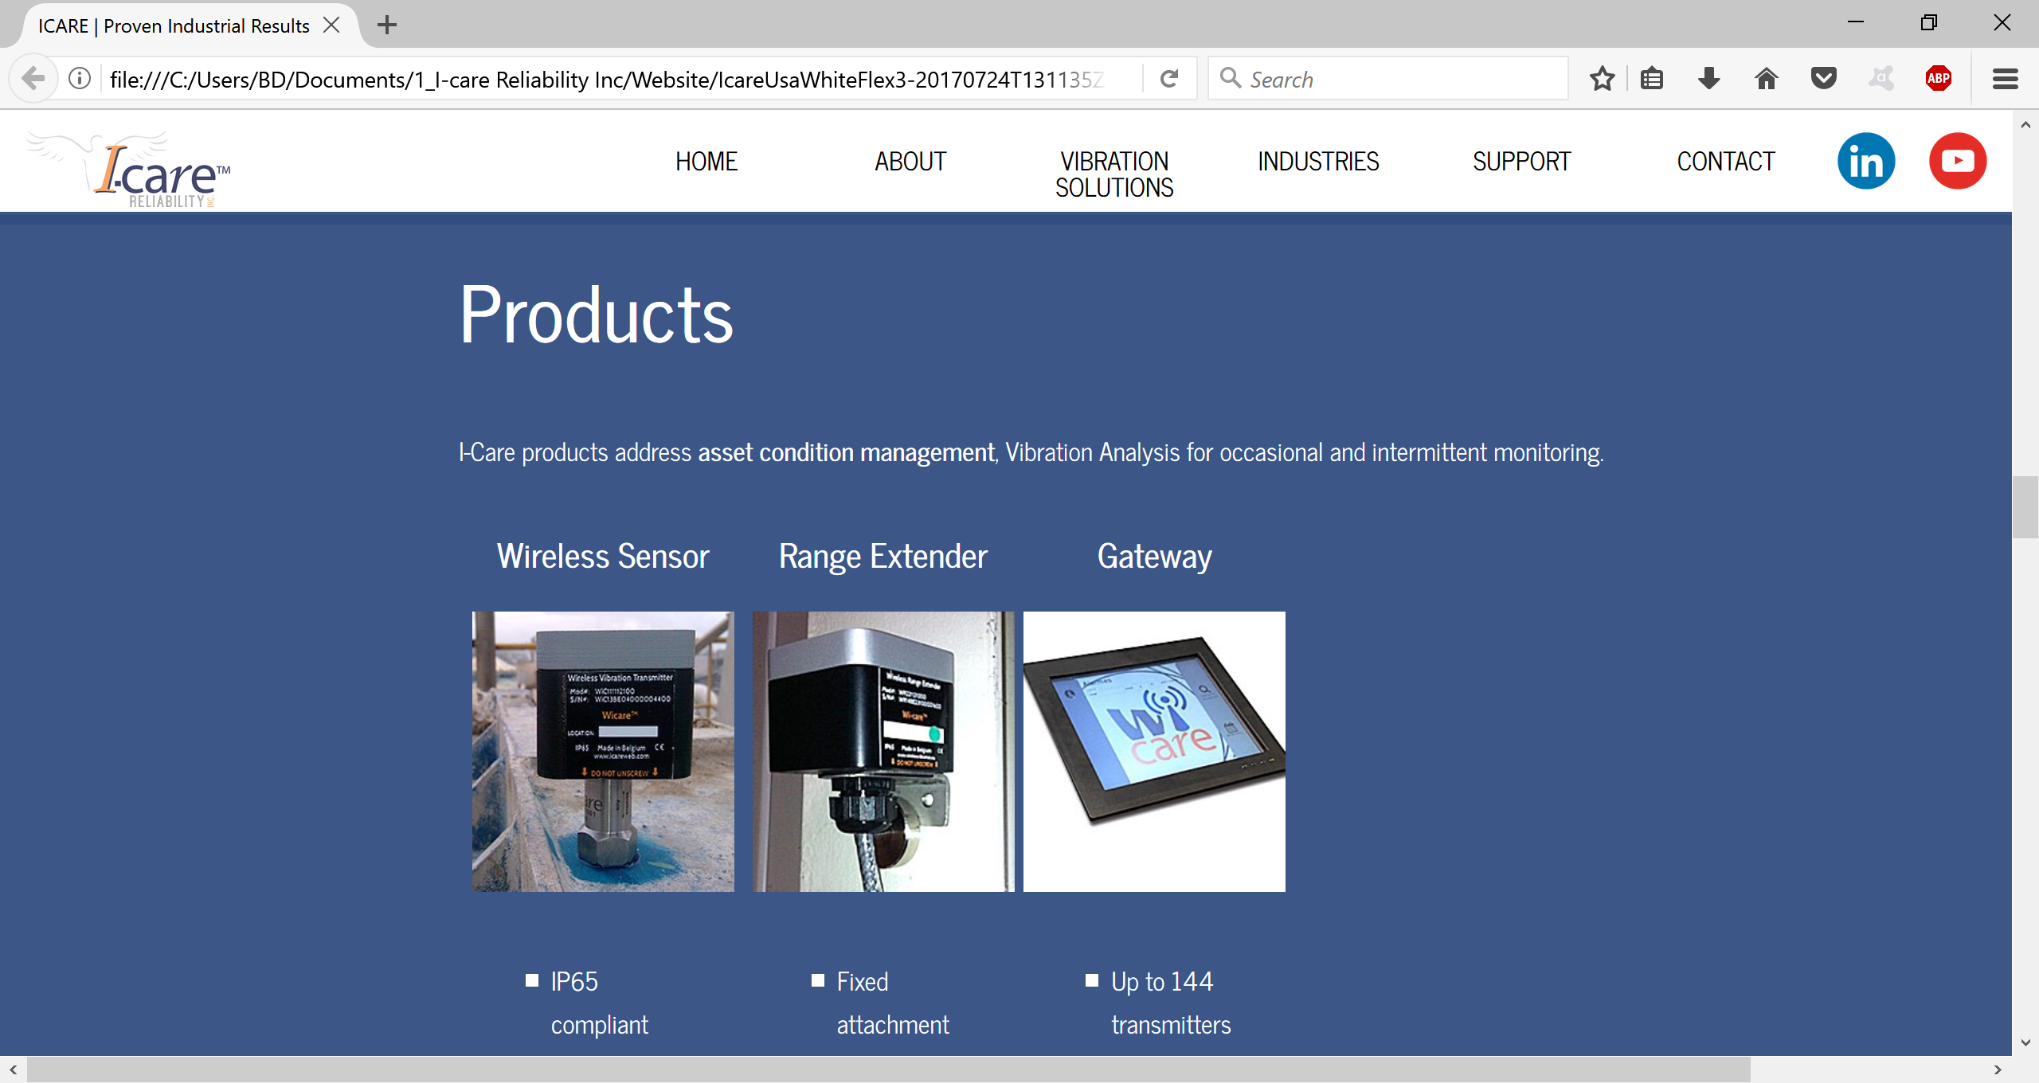

I would like to change the product page. Can you do 4 pictures next to each other with this 4 shorts text below the picture? Feel free to put the pictures at the right format.



**I-see**

I-see, I-care Reliability’s open, cloud-based data analytics dashboard, captures real-time data from any Wi-care transmitter. This IIoT platform is open to integration and is designed to centralize data, reporting and Kpi’s for multiple predictive technologies.

I-see includes an open API for easy interfacing with other platforms, enabling discrete asset or multiple plant management to Corporate Implementation. An up-to-date browser such as Google Chrome™, Microsoft Edge™ or Mozilla Firefox™ is all you need, no special software installation is required. The platform can be accessed anywhere on any portable or PC device and the Android App.

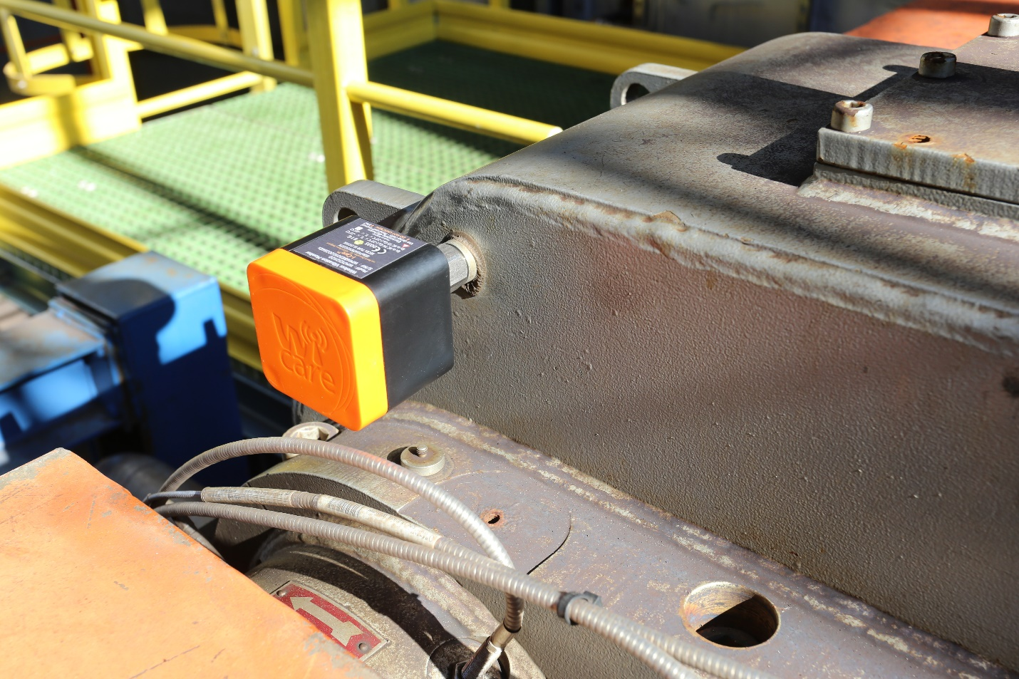

**Wi-care**

The Wi-care system is a wireless vibration and temperature monitoring solution. It allows you to track critical equipment automatically, from 15-minute to once-a-week intervals, collecting reliable vibration data, with sampling of up to 16,000 lines of resolution.

Snap it on, plug and play, deploy triax, Class1 Div1-certified accelerometers and enjoy long battery lifetime with Wi-care, likely the most performing wireless vibration system available. The sensors can be deployed and configured in less than an hour, whether for permanent or intermittent monitoring. Extended broadcast and automatic network capabilities guarantee data transmission reliability and sustainability to maximize your asset up-time.

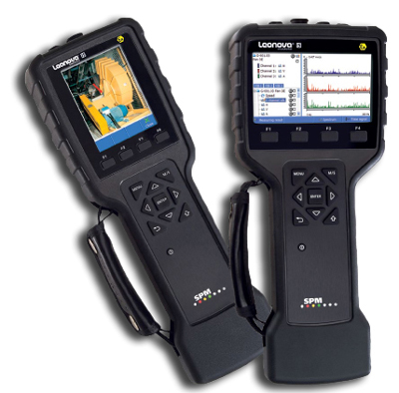

**Extensive solution range and expert consulting**

I-care Reliability also represents SPM and their on-line and off-line vibration products. For some 50 years, SPM has been developing and promoting high performance condition-monitoring solutions to the Process industry. SPM’s unique HD Technologies remain unsurpassed, particularly for low speed equipment and early fault detection on anti-friction bearings. This state-of-the-art vibration analysis technology is available both on the premium data collectors LEONOVA and on the INTELLINOVA online system.

Expert consulting expertise is available to augment your existing systems with fit-for-purpose I-care and SPM devices.

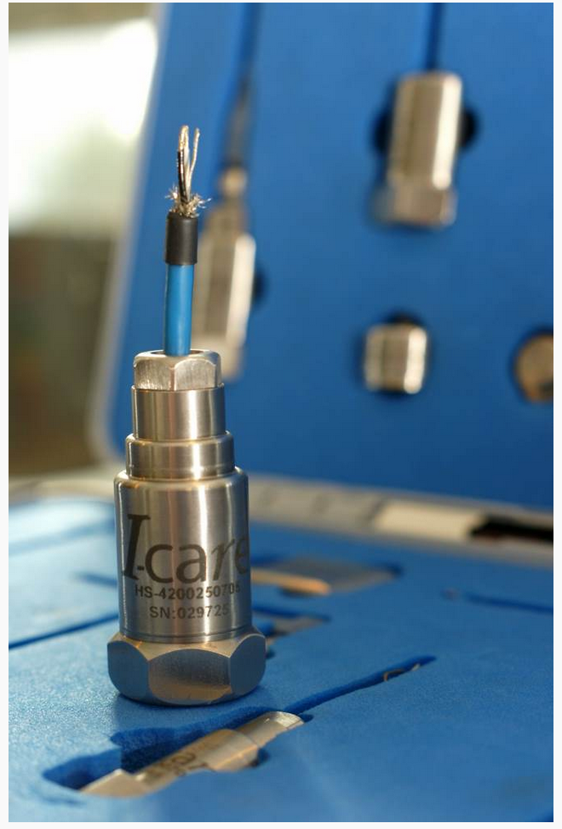

**Sensor flexibility**

I-care Reliability also offers a complete range of high performance vibration transducers ideally suited to your needs, distributed in partnership with a leading manufacturer.

Depending of specific requirements, constraints and implementation criteria, I-care will deliver the RIGHT sensor for your needs, built on ICP piezoelectric proven technology, low background noise, extended lifetime and high signal reliability. All devices can leverage 4-20mA application with connection to PLC or SNCC system, and include junction boxes and vibration switches for remote or hazardous placement locations.

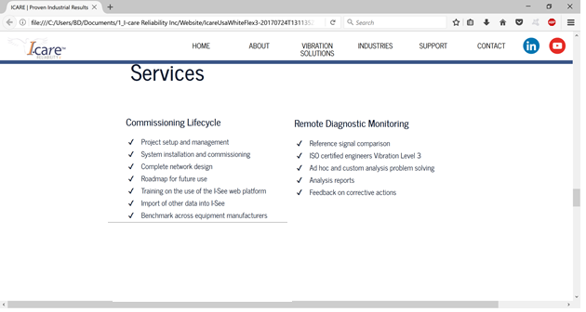

Can you put Remote diagnostic and commission lifecycle next to each other?

Also add in the commissioning lifecycle column:

* Condition monitoring consulting
* Vibration program audit
* On-site services

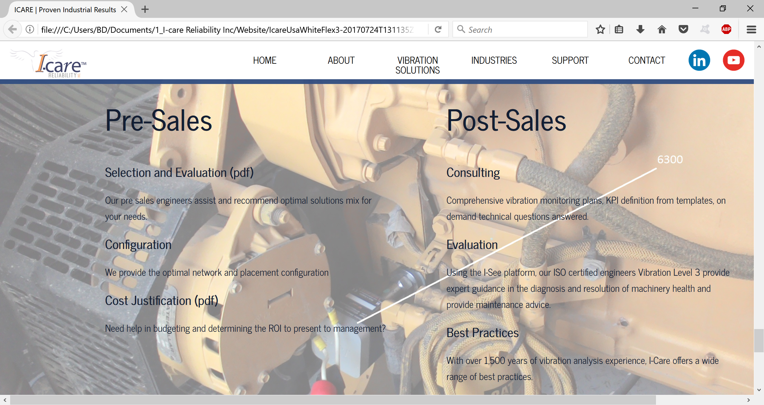

Can you put the same width for these 2 columns like on the regular layout of the website?

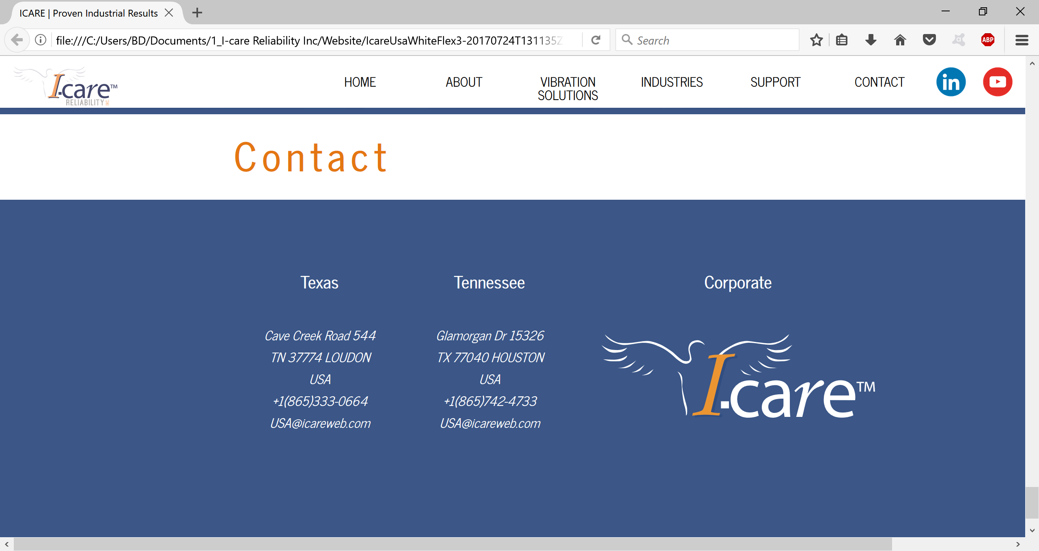

I would like to change a bit the contact page.

4 columns (same layout-width that for product) next to each other:

-Gulf Coast

15326 Glamorgan Drive

Houston, TX 77040

(865) 742-4733

[USA@icareweb.com](mailto:USA@icareweb.com)

-Southeast

544 Cave Creek Road

Loudon, TN 37774

(865) 333-0664

[USA@icareweb.com](mailto:USA@icareweb.com)

-California

1000 Sunset Boulevard

Los Angeles, CA 90005

(865) 454-4733

[USA@icareweb.com](mailto:USA@icareweb.com)

- Corporate offices (put the picture below with a link to contact page on the corporate website http://www.icareweb.com/contact-2-2/)

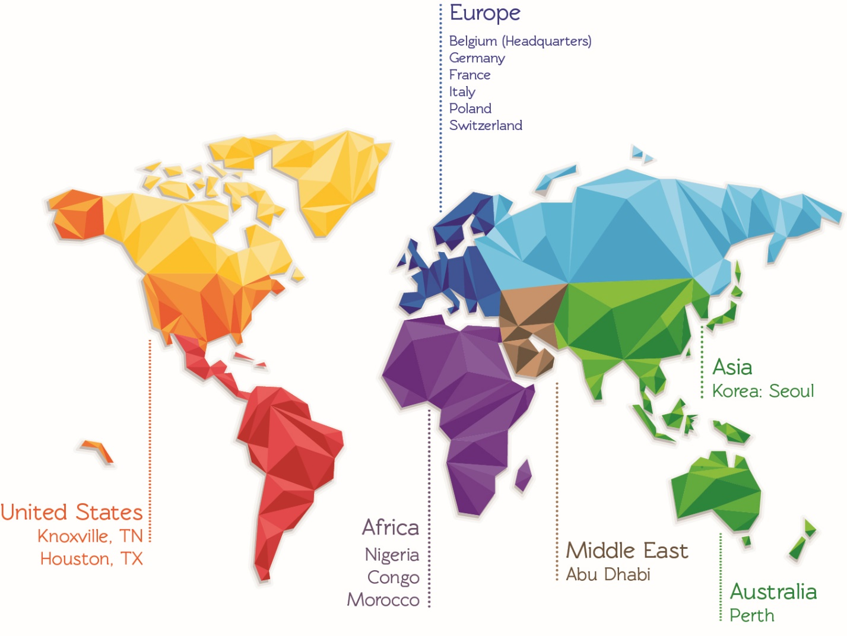

I would like also to put a place for signing up for our newsletter or for product info where the customer can leave its contact info. I don’t know if it’s better to put it on this page or on the first one, can you see with David what do you think would be the best place?

Many thanks!

Ben

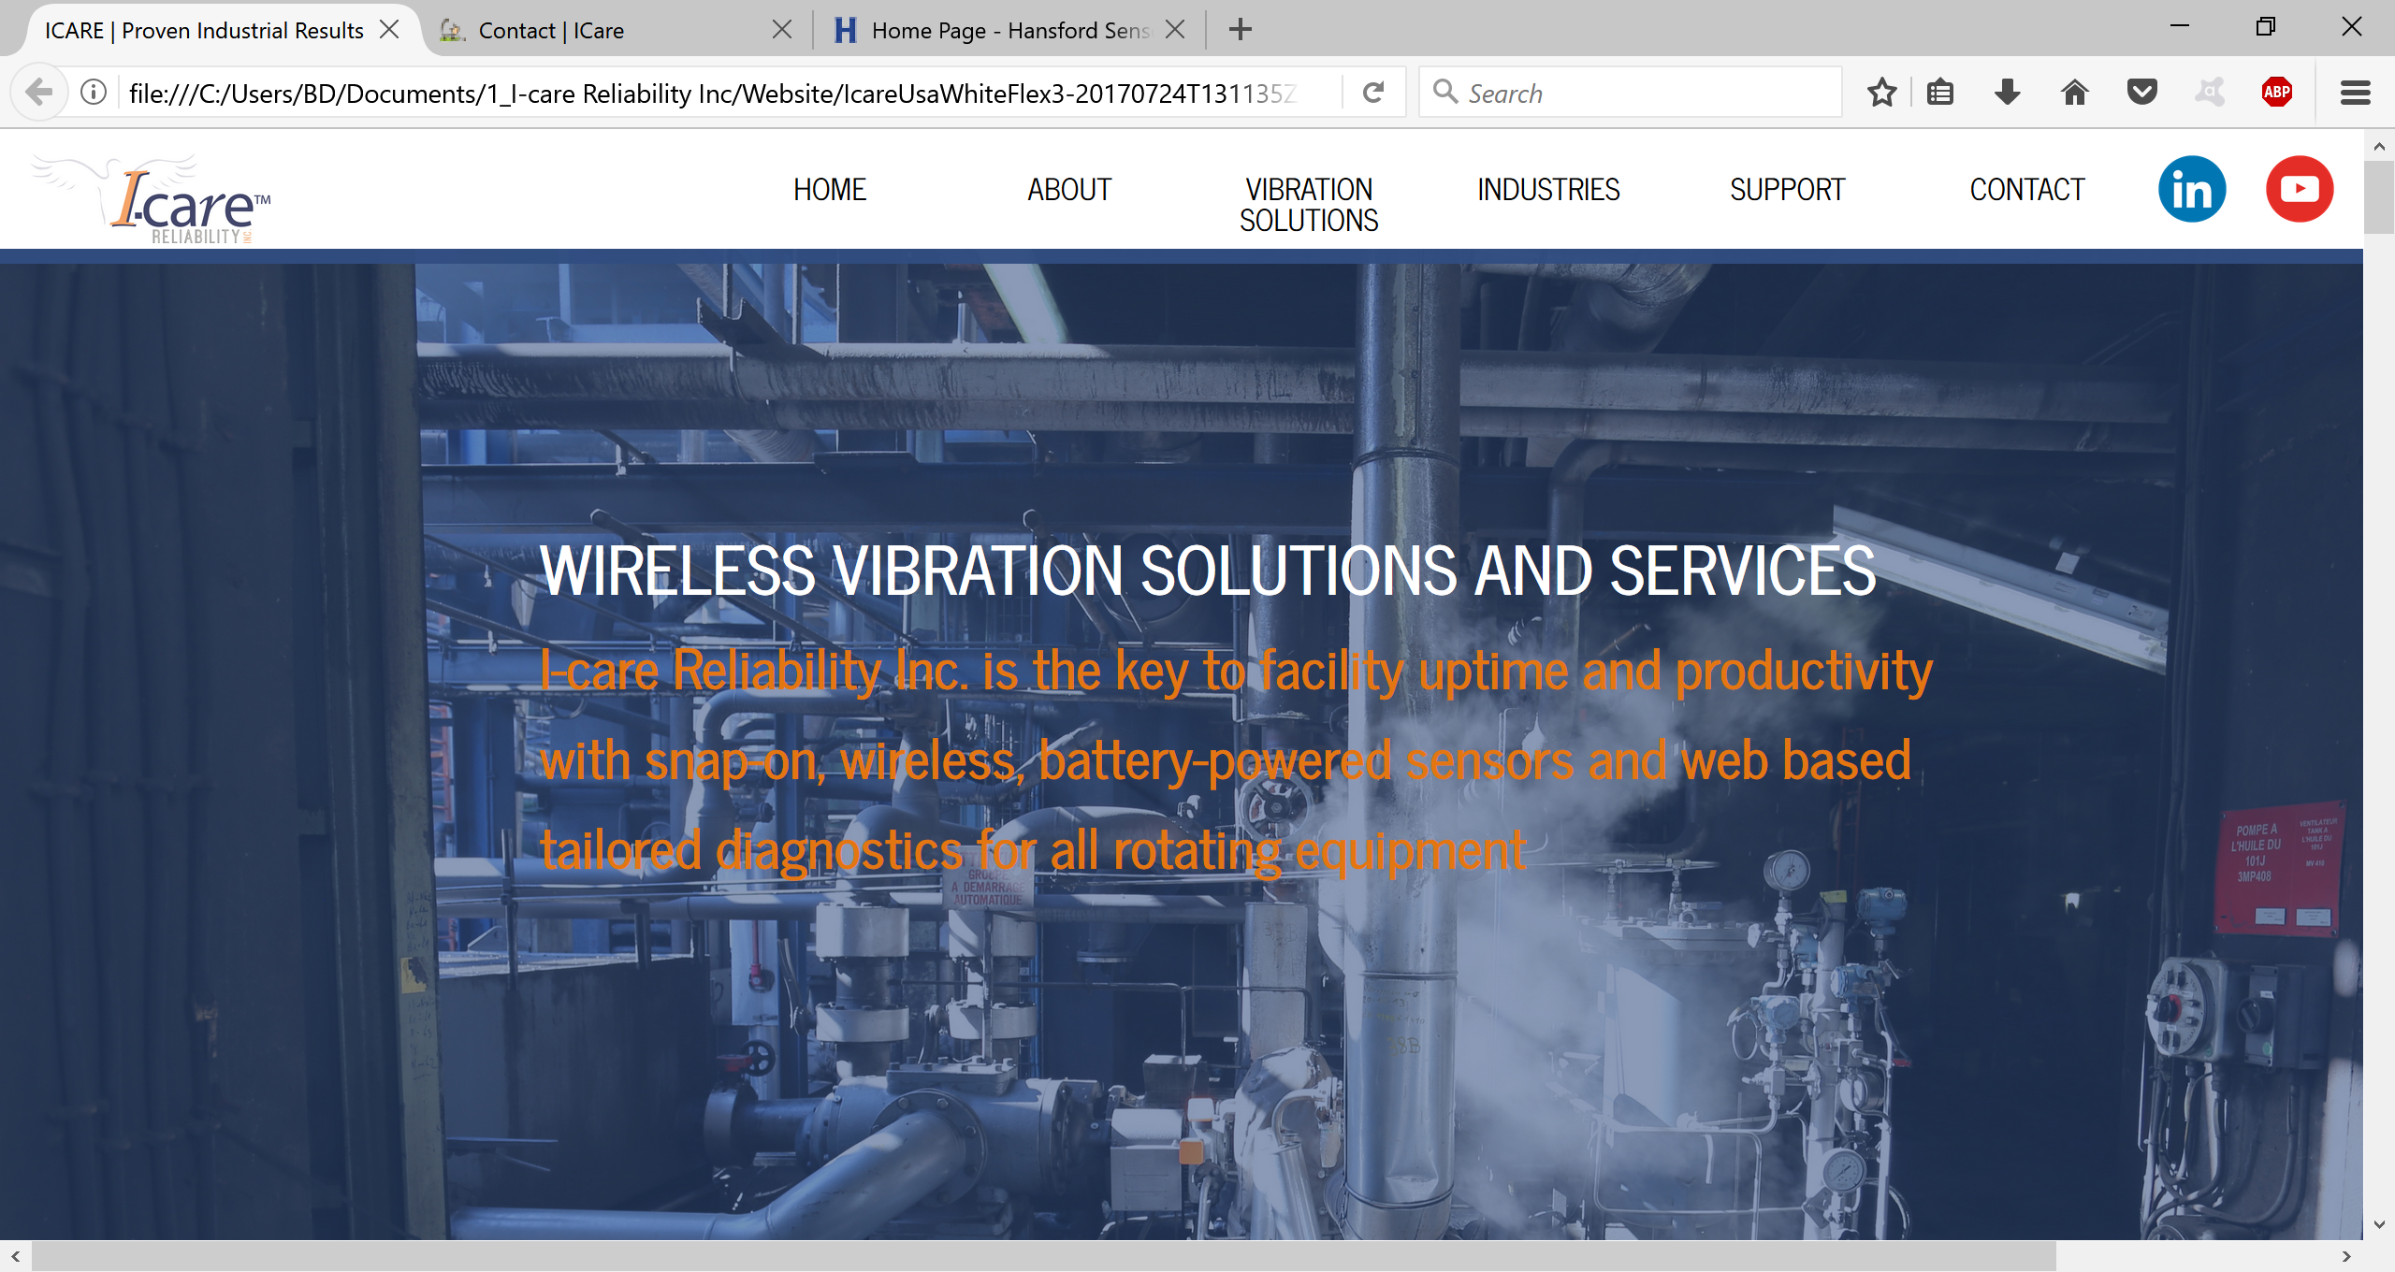

Can you link the Linkedin page of I-care Relability inc? and The Wi-care I-see Youtube channel?

<https://www.linkedin.com/in/i-care-reliability-457761110/>

<https://www.youtube.com/channel/UCQ-ne_q6kz9M53TB9KZfbww>